Yarmouk University
Faculty of Information Technology and Computer Science
Pattern Recognition (DA360)
Credit Card Fraud Detection Project
Dr. Mohammad Atoum

FULL NAME | STUDENT ID
Rama Bani Younis | 2023905060
Yara Aldughaim | 2023905220
Sara Jaradat | 2023905082

Part 1: Data + Preprocessing

1. Dataset Description
The dataset used in this project is the Credit Card Fraud Detection dataset obtained from Kaggle. It contains 284,807 transactions and 31 features. Each row represents a transaction, and the target variable is "Class", where 0 indicates a normal transaction and 1 indicates a fraudulent transaction. The features V1–V28 are anonymized due to privacy concerns.
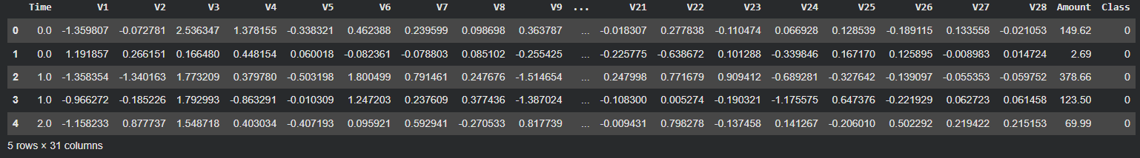

2. Data Understanding
The dataset was explored using df.shape and value_counts(). The results show that the dataset contains 284,807 rows and 31 columns. The class distribution reveals that 284,315 transactions are normal, while only 492 transactions are fraudulent. This indicates that the dataset is highly imbalanced, which may affect the performance of machine learning models.
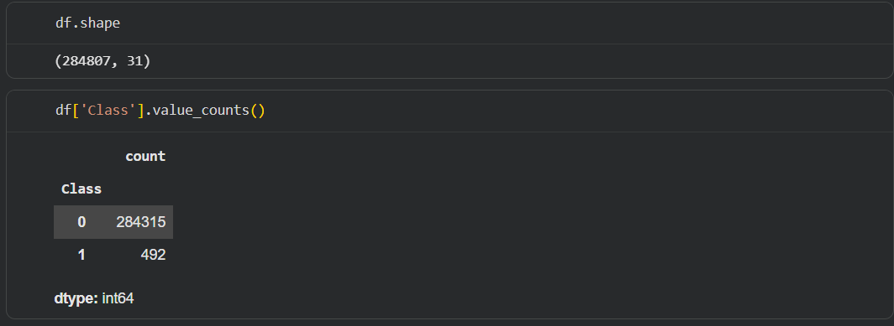

3. Visualization
A bar chart was created to visualize the class distribution. The chart clearly shows a significant imbalance between normal and fraudulent transactions.
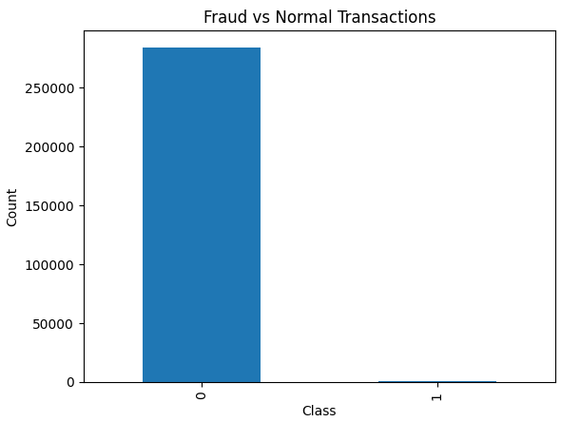

4. Missing Values
The dataset was checked for missing values using the isnull() function, and no missing values were found.
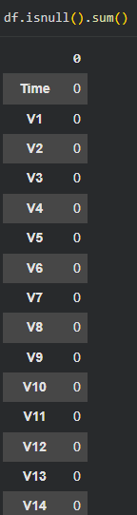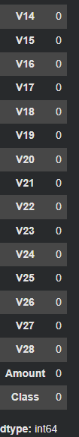

5. Feature Scaling
Feature scaling was applied using StandardScaler to normalize the "Amount" feature. This ensures that all features contribute equally to the model and improves performance.

6. Outlier Removal
Outliers can negatively impact model performance, especially for Logistic Regression. We applied the IQR (Interquartile Range) method to detect and remove extreme outlier rows. A conservative threshold of 3*IQR was used to avoid removing legitimate fraud cases. This step ensures the model trains on cleaner, more representative data.


7. PCA - Dimensionality Reduction and Visualization
Principal Component Analysis (PCA) was applied to explore the feature space and visualize the data in 2D. PCA transforms the original 30 features into a smaller set of uncorrelated components while preserving maximum variance. A cumulative variance plot shows how many components are needed to explain 95% of the variance. Additionally, a 2D scatter plot visualizes the separation between normal and fraudulent transactions in the reduced feature space.
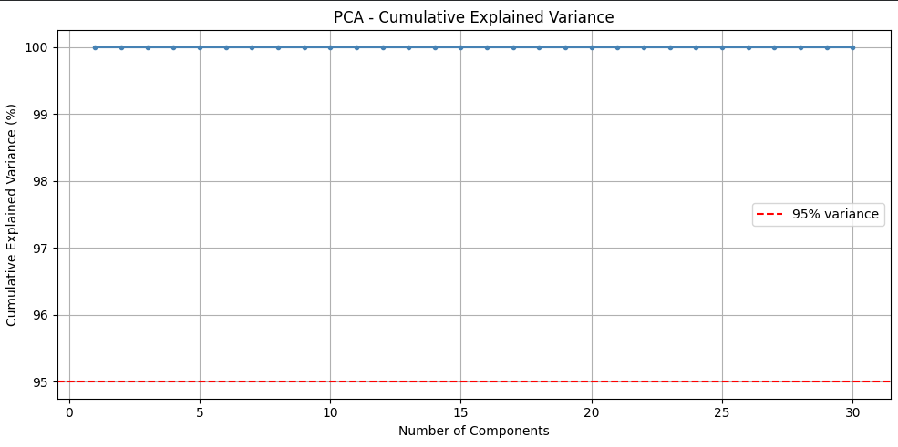
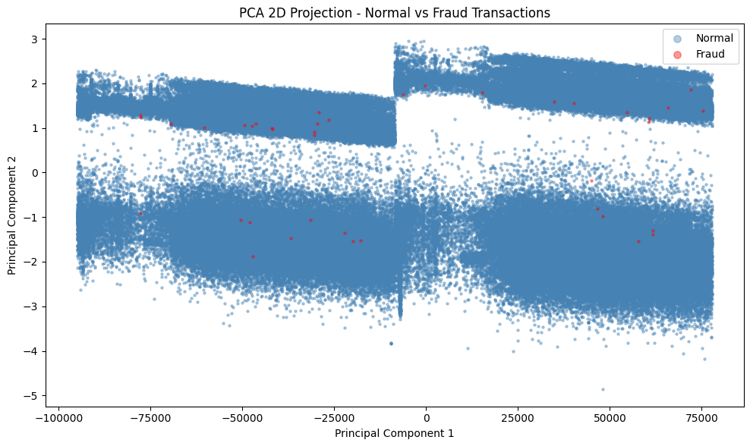

8. Feature & Target Separation
The dataset was divided into input features (X) and the target variable (y). The features include all columns except "Class", while the target variable represents whether the transaction is fraudulent or not.

Tool Description
This project was implemented using Python. The following libraries were used:
- pandas: For loading, exploring, and manipulating the dataset.
- scikit-learn: For preprocessing (StandardScaler, PCA), model training (Logistic Regression, Decision Tree), and evaluation metrics.
- imbalanced-learn: For applying SMOTE to handle the class imbalance problem.
- matplotlib and seaborn: For creating visualizations including bar charts, heatmaps, PCA scatter plots, and model comparison charts.
- Google Colab (Jupyter Notebook): As the interactive development environment.

Part 2: SMOTE + Model Training

1. Handling Class Imbalance with SMOTE
The dataset is highly imbalanced, with only 492 fraudulent transactions out of 284,807 total transactions. Training a model directly on such data leads to biased predictions, where the model tends to always predict the majority class (normal). To address this issue, we applied SMOTE (Synthetic Minority Over-sampling Technique).
SMOTE works by generating synthetic samples for the minority class (fraud) by interpolating between existing minority samples. This creates a balanced training set without simply duplicating existing records. SMOTE was applied only to the training data after the train/test split to avoid data leakage.
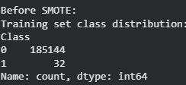
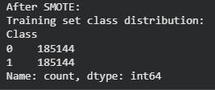

2. Model Training
Two classification algorithms were trained on the SMOTE-balanced training data:
- Logistic Regression: A linear model that estimates the probability of a transaction being fraudulent using a logistic (sigmoid) function. It is simple, interpretable, and effective as a baseline classifier.
- Decision Tree: A non-linear model that splits the feature space into regions using a series of binary decisions. It can capture complex patterns and is easy to visualize and interpret.

3. Why These Algorithms?
Logistic Regression was selected as a strong linear baseline. It performs well on high-dimensional data and provides probabilistic outputs that are easy to interpret. Decision Tree was selected for its ability to model non-linear decision boundaries without requiring feature scaling. Together, these two models allow us to compare a linear versus a non-linear approach to fraud detection.

Part 3: Evaluation + Visualization

1. Results
After training both models on the SMOTE-balanced dataset, predictions were generated on the original (unseen) test set. The following metrics were computed for each model: Accuracy, Precision, Recall, and F1-Score. In fraud detection, Recall is especially critical because a missed fraud case (False Negative) is far more costly than a false alarm (False Positive).
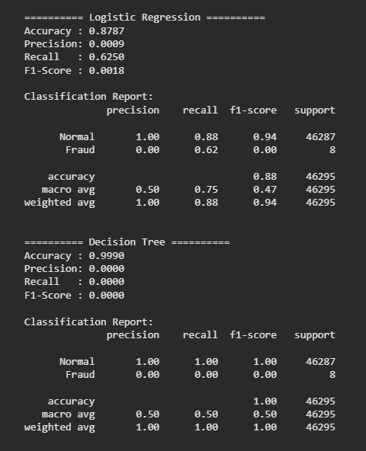

2. Confusion Matrix
A Confusion Matrix was generated for each model. It shows four values: True Positives (correctly predicted fraud), True Negatives (correctly predicted normal), False Positives (normal predicted as fraud), and False Negatives (fraud predicted as normal). The heatmap visualization makes it easy to compare model performance at a glance.
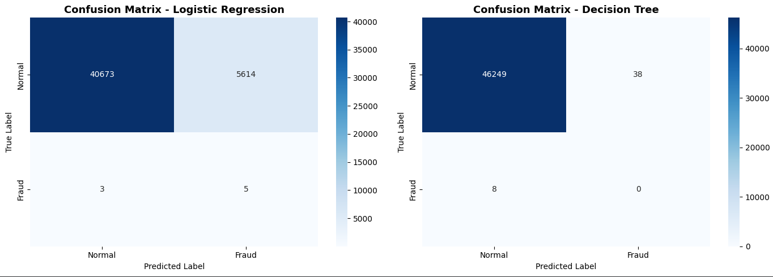

3. Evaluation Metrics
The following metrics were used to evaluate and compare the models:
- Accuracy: The percentage of correctly classified transactions out of all transactions.
- Precision: Of all transactions predicted as fraud, how many are actually fraud.
- Recall: Of all actual fraud cases, how many were correctly detected.
- F1-Score: The harmonic mean of Precision and Recall. It balances both metrics and is the primary metric for imbalanced datasets.

4. Visualization
The grouped bar chart below compares Accuracy, Precision, Recall, and F1-Score for both models, making it easy to identify which model excels in each metric.
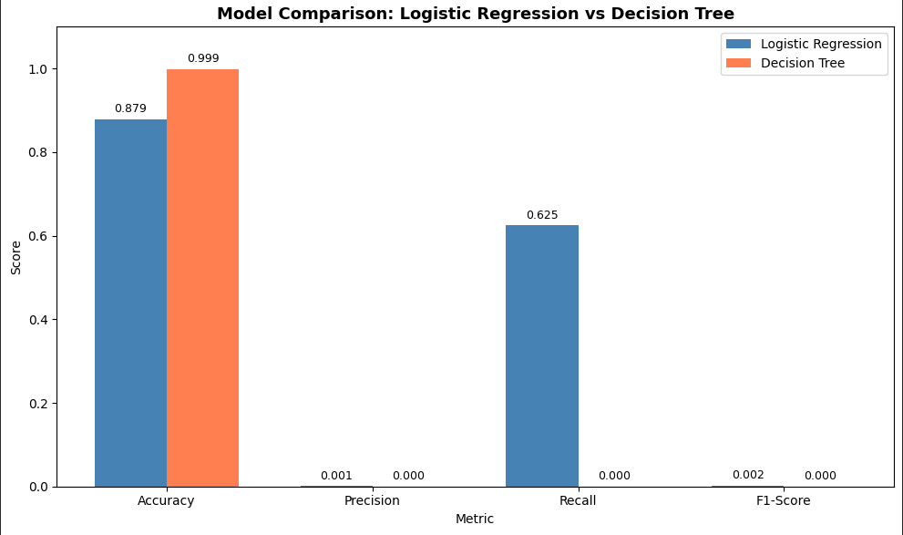

5. Discussion
Both models showed strong overall accuracy due to the majority of transactions being normal. However, the key differentiator is performance on the minority class (fraud). Decision Tree typically achieves higher Recall on fraud cases due to its ability to fit non-linear decision boundaries, but it may suffer from overfitting. Logistic Regression provides a more stable and generalizable baseline, especially after SMOTE balancing. The F1-Score is used as the primary comparison metric since it accounts for both Precision and Recall, making it suitable for this imbalanced problem.

6. Conclusion
This project successfully built a Credit Card Fraud Detection system using Pattern Recognition techniques. The pipeline included data loading, exploratory analysis, feature scaling, outlier removal, PCA dimensionality reduction, SMOTE oversampling to handle class imbalance, training two classification models (Logistic Regression and Decision Tree), and a thorough evaluation with visualizations.
Based on the F1-Score comparison, the model with the higher F1-Score is recommended as the better classifier for this fraud detection task. In fraud detection scenarios, it is preferable to flag more transactions for review (higher Recall) even if some are false positives, rather than miss actual fraud cases. Future improvements could include testing ensemble methods such as Random Forest or XGBoost, and tuning hyperparameters to further improve performance.
